
OPC Unified Architecture
Specification
Part 8: Data Access
Release Candidate 1.01.10
March 12, 2008

Specification Type | Industry Standard Specification
Title: | OPC Unified Architecture  Data Access | Date: | March 12, 2008
Version: | Release Candidate 1.01.10 | Software | MS-Word
 |  | Source: | 0000.doc
Author: | OPC Foundation | Status: | Release Candidate

CONTENTS
Page

FOREWORD v
AGREEMENT OF USE v
1 Scope 1
2 Reference documents 1
3 Terms, definitions, and abbreviations 1
3.1 OPC UA Part 1 terms 1
3.2 OPC UA Part 3 terms 1
3.3 OPC UA Part 4 terms 1
3.4 OPC UA Data Access terms 2
3.4.1 DataItem 2
3.4.2 AnalogItem 2
3.4.3 DiscreteItem 2
3.4.4 EngineeringUnits 2
3.5 Abbreviations and symbols 2
4 Concepts 3
5 Model 4
5.1 General 4
5.2 Variable Types 4
5.2.1 DataItemType 4
5.2.2 AnalogItemType 5
5.2.3 DiscreteItemType 6
5.3 Address Space Model 8
5.4 Attributes of DataItems 8
5.5 Property DataTypes 9
5.5.1 Overview 9
5.5.2 Range 9
5.5.3 EUInformation 10
6 Data Access specific usage of Services 11
6.1 PercentDeadband 11
6.2 Data Access Status Codes 11
6.2.1 Overview 11
6.2.2 Operation level result codes 11
6.2.3 LimitBits 12
6.2.4 SemanticsChanged 13

Figures
Figure 1 – OPC DataItems are linked to automation data 3
Figure 2 – DataItem VariableType Hierarchy 4
Figure 3 – Representation of DataItems in the AddressSpace 8

Tables
Table 1 – DataItemType Definition 4
Table 2 – AnalogItemType Definition 5
Table 3 – DiscreteItemType Definition 6
Table 4 – TwoStateDiscreteType Definition 6
Table 5 – MultiStateDiscreteType Definition 7
Table 6 – Range Data Type Structure 9
Table 7 – Range Definition 9
Table 8 – EUInformation Data Type Structure 10
Table 9 – EUInformation Definition 10
Table 10 – Bad operation level result codes 12
Table 11 – Uncertain operation level result codes 12
Table 12 – Good operation level result codes 12

OPC Foundation
____________

UNIFIED ARCHITECTURE –
FOREWORD
This specification is for developers of OPC UA clients and servers. The specification is a result of an analysis and design process to develop a standard interface to facilitate the development of servers and clients by multiple vendors that shall inter-operate seamlessly together.
Copyright © 2006-2008, OPC Foundation, Inc.
AGREEMENT OF USE
COPYRIGHT RESTRICTIONS
Any unauthorized use of this specification may violate copyright laws, trademark laws, and communications regulations and statutes. This document contains information which is protected by copyright. All Rights Reserved. No part of this work covered by copyright herein may be reproduced or used in any form or by any means--graphic, electronic, or mechanical, including photocopying, recording, taping, or information storage and retrieval systems--without permission of the copyright owner.
OPC Foundation members and non-members are prohibited from copying and redistributing this specification. All copies must be obtained on an individual basis, directly from the OPC Foundation Web site
http://www.opcfoundation.org.
PATENTS
The attention of adopters is directed to the possibility that compliance with or adoption of OPC specifications may require use of an invention covered by patent rights. OPC shall not be responsible for identifying patents for which a license may be required by any OPC specification, or for conducting legal inquiries into the legal validity or scope of those patents that are brought to its attention. OPC specifications are prospective and advisory only. Prospective users are responsible for protecting themselves against liability for infringement of patents.
WARRANTY AND LIABILITY DISCLAIMERS
WHILE THIS PUBLICATION IS BELIEVED TO BE ACCURATE, IT IS PROVIDED "AS IS" AND MAY CONTAIN ERRORS OR MISPRINTS. THE OPC FOUDATION MAKES NO WARRANTY OF ANY KIND, EXPRESSED OR IMPLIED, WITH REGARD TO THIS PUBLICATION, INCLUDING BUT NOT LIMITED TO ANY WARRANTY OF TITLE OR OWNERSHIP, IMPLIED WARRANTY OF MERCHANTABILITY OR WARRANTY OF FITNESS FOR A PARTICULAR PURPOSE OR USE. IN NO EVENT SHALL THE OPC FOUNDATION BE LIABLE FOR ERRORS CONTAINED HEREIN OR FOR DIRECT, INDIRECT, INCIDENTAL, SPECIAL, CONSEQUENTIAL, RELIANCE OR COVER DAMAGES, INCLUDING LOSS OF PROFITS, REVENUE, DATA OR USE, INCURRED BY ANY USER OR ANY THIRD PARTY IN CONNECTION WITH THE FURNISHING, PERFORMANCE, OR USE OF THIS MATERIAL, EVEN IF ADVISED OF THE POSSIBILITY OF SUCH DAMAGES.
The entire risk as to the quality and performance of software developed using this specification is borne by you.
RESTRICTED RIGHTS LEGEND
This Specification is provided with Restricted Rights. Use, duplication or disclosure by the U.S. government is subject to restrictions as set forth in (a) this Agreement pursuant to DFARs 227.7202-3(a); (b) subparagraph (c)(1)(i) of the Rights in Technical Data and Computer Software clause at DFARs 252.227-7013; or (c) the Commercial Computer Software Restricted Rights clause at FAR 52.227-19 subdivision (c)(1) and (2), as applicable. Contractor / manufacturer are the OPC Foundation,. 16101 N. 82nd Street, Suite 3B, Scottsdale, AZ, 85260-1830
COMPLIANCE
The OPC Foundation shall at all times be the sole entity that may authorize developers, suppliers and sellers of hardware and software to use certification marks, trademarks or other special designations to indicate compliance with these materials. Products developed using this specification may claim compliance or conformance with this specification if and only if the software satisfactorily meets the certification requirements set by the OPC Foundation. Products that do not meet these requirements may claim only that the product was based on this specification and must not claim compliance or conformance with this specification.
Trademarks
Most computer and software brand names have trademarks or registered trademarks. The individual trademarks have not been listed here.
GENERAL PROVISIONS
Should any provision of this Agreement be held to be void, invalid, unenforceable or illegal by a court, the validity and enforceability of the other provisions shall not be affected thereby.
This Agreement shall be governed by and construed under the laws of the State of Minnesota, excluding its choice or law rules.
This Agreement embodies the entire understanding between the parties with respect to, and supersedes any prior understanding or agreement (oral or written) relating to, this specification.
ISSUE REPORTING
The OPC Foundation strives to maintain the highest quality standards for its published specifications, hence they undergo constant review and refinement. Readers are encouraged to report any issues and view any existing errata here:
http://www.opcfoundation.org/errata

Scope
This specification is part of the overall OPC Unified Architecture (OPC UA) specification series and defines the information model associated with Data Access (DA). It particularly includes additional VariableTypes and complemental descriptions of the NodeClasses and Attributes needed for Data Access, additional Properties and other information and behaviour.
The complete address space model, including all NodeClasses and Attributes, is specified in Part 3. The services to detect and access data are specified in Part 4.

Reference documents
Part 1: OPC UA Specification: Part 1 – Concepts, Version 1.0 or later
http://www.opcfoundation.org/UA/Part1/
Part 3: OPC UA Specification: Part 3 – Address Space Model, Version 1.0 or later
http://www.opcfoundation.org/UA/Part3/
Part 4: OPC UA Specification: Part 4 – Sevices, Version 1.0 or later
http://www.opcfoundation.org/UA/Part4/
Part 5: OPC UA Specification: Part 5 – Information Model, Version 1.0 or later
http://www.opcfoundation.org/UA/Part5/

Terms, definitions, and abbreviations

OPC UA Part 1 terms
The following terms defined in Part 1 apply.
- AddressSpace
- Node
- NodeClass
- Reference
- Subscription
- View

OPC UA Part 3 terms
The following terms defined in Part 3 apply.
- DataVariable
- Object
- Property
- Variable
- VariableType

OPC UA Part 4 terms
The following terms defined in Part 4 apply.
- Deadband

OPC UA Data Access terms

DataItem
a link to arbitrary, live automation data, i.e. data that represents currently valid information.
NOTE: Examples of such data are
- device data (such as temperature sensors)
- calculated data
- status information (open/closed, moving)
- dynamically-changing system data (such as stock quotes)
- diagnostic data

AnalogItem
DataItems that represent continuously-variable physical quantities.
NOTE: Typical examples are the values provided by temperature sensors or pressure sensors. OPC UA defines a specific VariableType to identify an AnalogItem. Properties describe the possible ranges of AnalogItems.

DiscreteItem
DataItems that represent data that may take on only a certain number of possible values.
NOTE: Specific VariableTypes are used to identify DiscreteItems with two states or with multiple states. Properties specify the string values for these states.

EngineeringUnits
the units of measurement for AnalogItems that represent continuously-variable physical quantities (e.g., length, mass, time, temperature).
NOTE: This Part defines Properties to inform about the unit used for the DataItem value and about the highest and lowest value likely to be obtained in normal operation.

Abbreviations and symbols
DA Data Access
EU Engineering Unit
UA Unified Architecture

Concepts
Data Access deals with the representation and use of automation data in OPC UA Servers.
Automation data can be located inside the OPC UA Server or on I/O cards directly connected to the OPC UA Server. It can also be located in sub-servers or on other devices such as controllers and input/output modules, connected by serial links via field buses or other communication links. OPC UA Data Access Servers provide one or more OPC UA Data Access Clients with transparent access to their automation data.
The links to automation data instances are called DataItems. Which categories of automation data are provided is completely vendor-specific. Figure 1 illustrates how the AddressSpace of an OPC UA server might consist of a broad range of different DataItems.
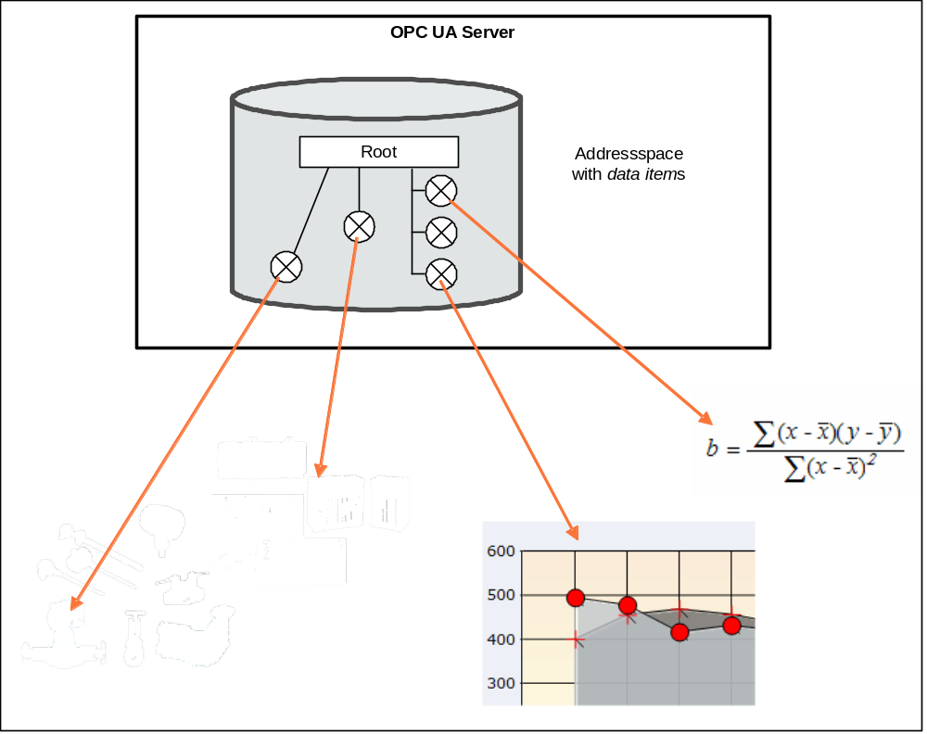
Figure 1 – OPC DataItems are linked to automation data
Clients may read or write DataItems, or monitor them for value changes. The services needed for these operations are specified in Part 4. Changes are defined as a change in status (quality) or a change in value that exceeds a client-defined range called a Deadband. To detect the value change, the difference between the current value and the last reported value is compared to the Deadband.

Model

General
The DataAccess model extends the variable model by defining VariableTypes. The DataItemType is the base type. AnalogType and DiscreteType (and its TwoState and MultiState subtypes) are specializations. Each of these VariableTypes can be further extended to form domain or server specific DataItems.
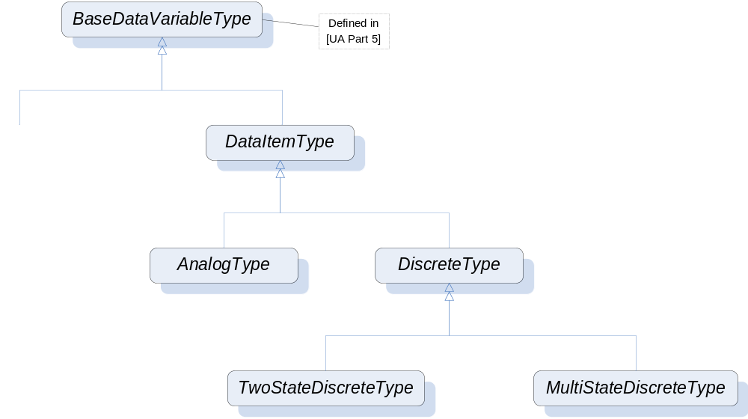
Figure 2 – DataItem VariableType Hierarchy

Variable Types

DataItemType
This VariableType defines the general characteristics of a DataItem. All other DataItem Types derive from it. The DataItemType derives from the BaseDataVariableType and therefore shares the variable model as described in Part 3 and Part 5. It is formally defined in Table 1.
Table 1 – DataItemType Definition

Attribute | Value
BrowseName | DataItemType
IsAbstract | False
ValueRank | -2 (-2 = ‘Any’)
DataType | BaseDataType
References | NodeClass | BrowseName | DataType | TypeDefinition | ModellingRule
Inherit the Properties of the BaseDataVariableType defined in Part 5
HasSubtype | VariableType | AnalogItemType | Defined in Clause 5.2.2
HasSubtype | VariableType | DiscreteItemType | Defined in Clause 5.2.3
HasProperty | Variable | Definition | String | PropertyType | Optional
HasProperty | Variable | ValuePrecision | Double | PropertyType | Optional

Definition is a vendor-specific, human readable string that specifies how the value of this DataItem is calculated. Definition is non-localized and will often contain an equation that can be parsed by certain clients.
Example: Definition ::= “(TempA – 25) + TempB”
ValuePrecision specifies the maximum precision that the server can maintain for the item based on restrictions in the target environment.
ValuePrecision can be used for the following DataTypes:
- For Float and Double values it specifies the number of digits after the decimal place.
- For DateTime values it indicates the minimum time difference in nanoseconds. E.g., a ValuePrecision of 20.000.000 defines a precision of 20 milliseconds.
The ValuePrecision property is an approximation that is intended to provide guidance to a client. A server is expected to silently round any value with more precision that it supports. This implies that a client may encounter cases where the value read back from a server differs from the value that it wrote to the server. This difference must be no more than the difference suggested by this property.

AnalogItemType
This VariableType defines the general characteristics of an AnalogItem. All other AnalogItem Types derive from it. The AnalogItemType derives from the DataItemType. It is formally defined in Table 2.
Table 2 – AnalogItemType Definition

Attribute | Value
BrowseName | AnalogItemType
IsAbstract | False
ValueRank | -2 (-2 = ‘Any’)
DataType | Number
References |  | NodeClass | BrowseName | DataType | TypeDefinition | ModellingRule
Inherit the Properties of the DataItemType defined in Clause 5.2
HasProperty |  | Variable | InstrumentRange | Range | PropertyType | Optional
HasProperty |  | Variable | EURange | Range | PropertyType | Mandatory
HasProperty |  | Variable | EngineeringUnits | EUInformation | PropertyType | Optional

InstrumentRange defines the value range that can be returned by the instrument.
Example: InstrumentRange ::= {-9999.9, 9999.9}
The Range type is specified in clause 5.5.2.
EURange defines the value range likely to be obtained in normal operation. It is intended for such use as automatically scaling a bar graph display.
Sensor or instrument failure or deactivation can result in a returned item value which is actually outside this range. Client software must be prepared to deal with this. Similarly a client may attempt to write a value that is outside this range back to the server. The exact behaviour (accept, reject, clamp, etc.) in this case is server-dependent. However in general servers must be prepared to handle this.
Example: EURange ::= {-200.0,1400.0}

See also clause 6.1 for a special monitoring filter (PercentDeadband) which is based on the engineering unit range.
EngineeringUnits specifies the units for the DataItem’s value (e.g., DEGC, hertz, seconds).
The EUInformation type is specified in clause 5.5.3.
If the item contains an array the Properties will apply to all elements in the array.

DiscreteItemType
This VariableType is an abstract type. I.e., no instances of this type can exist. However, it might be used in a filter when browsing or querying. The DiscreteItemType derives from the DataItemType and therefore shares all of its characteristics. It is formally defined in Table 3.
Table 3 – DiscreteItemType Definition

Attribute | Value
BrowseName | DiscreteItemType
IsAbstract | True
ValueRank | -2 (-2 = ‘Any’)
DataType | BaseDataType
References | NodeClass | BrowseName | DataType | TypeDefinition | ModellingRule
Inherit the Properties of the DataItemType defined in Clause 5.2
HasSubtype | VariableType | TwoStateDiscreteType | Defined in Clause 5.2.3.1
HasSubtype | VariableType | MultiStateDiscreteType | Defined in Clause

TwoStateDiscreteType
This VariableType defines the general characteristics of a DiscreteItem that can have two states. The TwoStateDiscreteType derives from the DiscreteItemType. It is formally defined in Table 4.
Table 4 – TwoStateDiscreteType Definition

Attribute | Value
BrowseName | TwoStateDiscreteType
IsAbstract | False
ValueRank | -2 (-2 = ‘Any’)
DataType | Boolean
References | NodeClass | BrowseName | DataType | TypeDefinition | ModellingRule
Inherit the Properties of the DiscreteItemType defined in Clause 5.2.3
HasProperty | Variable | TrueState | LocalizedText | PropertyType | Mandatory
HasProperty | Variable | FalseState | LocalizedText | PropertyType | Mandatory

TrueState contains a string to be associated with this DataItem when it is TRUE. This is typically used for a contact when it is in the closed (non-zero) state.
e.g. "RUN", "CLOSE", "ENABLE", "SAFE“, etc.
FalseState contains a string to be associated with this DataItem when it is FALSE. This is typically used for a contact when it is in the open (zero) state.
e.g. "STOP", "OPEN", "DISABLE", "UNSAFE“, etc.
If the item contains an array the Properties will apply to all elements in the array.

MultiStateDiscreteType
This VariableType defines the general characteristics of a DiscreteItem that can have more than two states. The MultiStateDiscreteType derives from the DiscreteItemType. It is formally defined in Table 5.
Table 5 – MultiStateDiscreteType Definition

Attribute | Value
BrowseName | MultiStateDiscreteType
IsAbstract | False
ValueRank | -2 (-2 = ‘Any’)
DataType | UInteger
References | NodeClass | BrowseName | DataType | TypeDefinition | ModellingRule
Inherit the Properties of the DiscreteItemType defined in Clause 5.2.3
HasProperty | Variable | EnumStrings | LocalizedText[] | PropertyType | Mandatory

EnumStrings is a string lookup table corresponding to sequential numeric values (0, 1, 2, etc.)
Example:
”OPEN”
”CLOSE”
”IN TRANSIT” etc.
Here the string “OPEN” corresponds to 0, “Close” to 1 and “IN TRANSIT” to 2.
Clients should be prepared to handle item values outside the range of the list and robust servers should be prepared to handle writes of illegal values.
If the item contains an array this lookup table will apply to all elements in the array.
NOTE: The EnumStrings property is also used for Enumeration DataTypes (for the specification of this DataType see Part 3).

Address Space Model
DataItems are always defined as data components of other Nodes in the AddressSpace. They are never defined by themselves. A simple example of a container for DataItems would be a “Folder Object” but it can be an Object of any other type.
Figure 3 illustrates the basic AddressSpace model of a DataItem – in this case an AnalogItem.
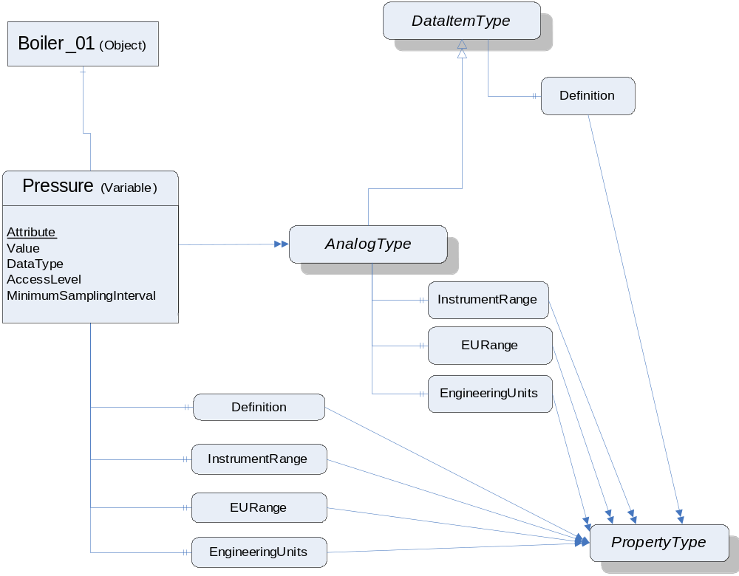
Figure 3 – Representation of DataItems in the AddressSpace
Each DataItem is represented by a DataVariable with a specific set of Attributes. The TypeDefinition reference indicates the type of the DataItem (in this case the AnalogType). Additional characteristics of DataItems are defined using Properties. The VariableTypes in Clause Error: Reference source not found specify which properties may exist. These Properties have been found useful for a wide range of Data Access clients. Servers that want to disclose similar information should use the OPC-defined Property rather than a vendor-specific one.
The above figure shows only a subset of Attributes and Properties. Other Attributes as defined for Variables in Part 3 (e.g., Description) may also be available.

Attributes of DataItems
This section lists the Attributes of Variables that have particular importance for Data Access. They are specified in detail in Part 3. The following Attributes are particularly important for Data Access:
- Value
- DataType
- AccessLevel
- MinimumSamplingInterval
Value is the most recent value of the Variable that the server has. Its data type is defined by the DataType Attribute. The AccessLevel Attribute defines the server’s basic ability to access current data and MinimumSamplingInterval defines how current the data are.
When a client requests the Value Attribute for reading or monitoring, the server always returns a StatusCode (the quality and the server’s ability to access/provide the value) and, optionally, a ServerTimestamp and a SourceTimestamp. See Part 4 for details on StatusCode and the meaning of the two timestamps. Specific status codes for Data Access are defined in clause 6.2.

Property DataTypes

Overview
Following is a description of the data types used for Data Access properties defined in this part.
DataTypes like String, Boolean, Double or LocalizedText are defined in Part 3. Their representation is specified in Part 5.

Range
This structure defines the Range for a value. Its elements are defined in Table 6.
Table 6 – Range Data Type Structure
Name | Type | Description
Range | structure
low | Double | Lowest value in the range.
high | Double | Highest value in the range.

Its representation in the AddressSpace is defined in Table 7
Table 7 – Range Definition
Attributes | Value
BrowseName | Range

EUInformation
This structure contains information about the EngineeringUnits. Its elements are defined in Table 8.
The structure has been defined such that standards bodies can incorporate their engineering unit definitions into OPC UA. Servers will use the namespaceUri in this structure to identify the proper organization.
Table 8 – EUInformation Data Type Structure
Name | Type | Description
EUInformation | structure
namespaceUri | String | Identifies the organization (company, standards organization) that defines the EUInformation.
unitId | Int32 | Identifier for programmatic evaluation.  - 1 is used if a unitId is not available.
displayName | LocalizedText | The displayName of the engineering unit is typically the abbreviation of the engineering unit, e.g. ”h” for hour or ”m/s” for meter per second.
description | LocalizedText | Contains the full name of the engineering unit such as ”hour” or ”meter per second”.

Its representation in the AddressSpace is defined in Table 9
Table 9 – EUInformation Definition
Attributes | Value
BrowseName | EUInformation
.

Data Access specific usage of Services
Part 4 specifies the complete set of services. Those needed for the purpose of DataAccess are in particular:
- The View service set and Query service set to detect DataItems, and their Properties.
- The Attribute service set to read or write Attributes and in particular the value Attribute.
- The MonitoredItem and Subscription service set to set up monitoring of DataItems and to receive data change notifications.

PercentDeadband
The DataChangeFilter in Part 4 defines the conditions under which a data change notification must be reported. This filter contains a deadband which can be of type AbsoluteDeadband or PercentDeadband. Part 4 already specifies the behaviour of the AbsoluteDeadband. This clause specifies the behaviour of the PercentDeadband type.
DeadbandType = PercentDeadband:
For this type of deadband the deadbandValue is defined as the percentage of the EURange. That is, it applies only to AnalogItems with an EURange Property that defines the typical value range for the item. This range will be multiplied with the deadbandValue to generate an exception limit. An exception is determined as follows:
Exception if (absolute value of (last cached value - current value) >
(deadbandValue/100.0) * ((high–low) of EURange)))
If the item is an array of values and any array element exceeds the deadbandValue, the entire monitored array is returned.

Data Access Status Codes

Overview
This section defines additional codes and rules that apply to the StatusCode when used for Data Access values.
The general structure of the StatusCode is specified in Part 4. It includes a set of common operational result codes that also apply to Data Access.

Operation level result codes
Certain conditions under which a Variable value was generated are only valid for automation data and in particular for device data. They are similar, but slightly more generic than the description of data quality in the various fieldbus specifications.
In the following, Table 10 contains codes with BAD severity, indicating a failure; contains codes with UNCERTAIN severity, indicating that the value has been generated under sub-normal conditions. contains GOOD (success) codes.
Note again, that these are the codes that are specific for Data Access and supplement the codes that apply to all types of data and are therefore defined in Part 4.
Table 10 – Bad operation level result codes
Symbolic Id | Description
Bad_ConfigurationError | There is a problem with the configuration that affects the usefulness of the value.
Bad_NotConnected | The variable should receive its value from another variable, but has never been configured to do so.
Bad_DeviceFailure | There has been a failure in the device/data source that generates the value that has affected the value.
Bad_SensorFailure | There has been a failure in the sensor from which the value is derived by the device/data source.  The limits bits are used to define if the limits of the value have been reached.
Bad_NoCommunication | Communications to the data source is defined, but not established, and there is no last known value available. This status/substatus is used for cached values before the first value is received.
Bad_OutOfService | The source of the data is not operational.
Bad_DeadbandFilterInvalid | The specified PercentDeadband is not supported, since an EURange is not configured.

Table 11 – Uncertain operation level result codes
Symbolic Id | Description
Uncertain_ NoCommunicationLastUsable | Communication to the data source has failed. The variable value is the last value that had a good quality and it is uncertain whether this value is still current.  The server timestamp in this case is the last time that the communication status was checked. The time at which the value was last verified to be true is no longer available.
Uncertain_  LastUsableValue | Whatever was updating this value has stopped doing so. This happens when an input variable is configured to receive its value from another variable and this configuration is cleared after one or more values have been received.  This status/substatus is not used to indicate that a value is stale. Stale data can be detected by the client looking at the timestamps.
Uncertain_SubstituteValue | The value is an operational value that was manually overwritten.
Uncertain_InitialValue | The value is an initial value for a variable that normally receives its value from another variable. This status/substatus is set only during configuration while the variable is not operational (while it is out-of-service).
Uncertain_  SensorNotAccurate | The value is at one of the sensor limits. The Limits bits define which limit has been reached. Also set if the device can determine that the sensor has reduced accuracy (e.g. degraded analyzer), in which case the Limits bits indicate that the value is not limited.
Uncertain_ EngineeringUnitsExceeded | The value is outside of the range of values defined for this parameter. The Limits bits indicate which limit has been reached or exceeded.
Uncertain_SubNormal | The value is derived from multiple sources and has less than the required number of Good sources.

Table 12 – Good operation level result codes
Symbolic Id | Description
Good_LocalOverride | The value has been Overridden. Typically this is means the input has been disconnected and a manually-entered value has been ”forced”.

LimitBits
The bottom 16 bits of the StatusCode are bit flags that contain additional information, but do not affect the meaning of the StatusCode. Of particular interest for DataItems is the LimitBits field. In some cases, such as sensor failure it can provide useful diagnostic information.

Servers that do not support Limit have to set this field to 0.

SemanticsChanged
The StatusCode also contains an informational bit called SemanticsChanged.
OPC UA Servers that implement Data Access must set this Bit in notifications if one or several of the following Properties changes:
- EngineeringUnits (could create problems if the client uses the value to perform calculations)
- EURange (could change the behaviour of a Subscription if a PercentDeadband filter is used)
- FalseState, TrueState, EnumStrings (changes can cause misinterpretation by users or (scripting) programs)
It should not be changed for any of the other Data Access Properties.
Clients should not process the data value until they re-read the mentioned Properties associated with the Variable.

